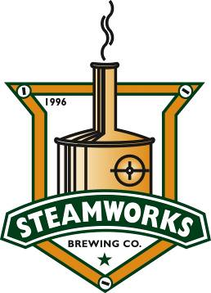

September 5, 2014

News
For further information, contact: Steamworks Co-Founders
Kris Oyler, 970.769.0776, or Brian McEachron, 970.799.3481

Steamworks steps back in time for 18th Anniversary celebration
Popular brewpub will roll back cost of pints and pitchers to 1996 price
DURANGO, Colo. – Steamworks Brewing Co. will celebrate its 18th Anniversary on Sunday, Sept. 14, 2014, with a “step back in time.” Patrons who visit the brewpub on Sept. 14 will enjoy the 1996 price for pints and pitchers of Steamworks’ award-winning craft beers.
“We’re rolling back beer prices to celebrate our anniversary and thank the community that has supported Steamworks throughout all these years. We couldn’t have done it without Durango,” said Kris Oyler, Steamworks co-founder. “We will be selling pints for $2.50 and pitchers for $10 all day.”
In 1996, Steamworks Brewing Co. caused a stir throughout Durango as Oyler and co-founder Brian McEachron transformed what once had been a circa 1920s motor works into a brewpub. Today, after all the trials and successes, the brewpub is a thriving local business, a respected employer, and Steamworks beers have earned numerous national and international awards, helping to put Durango on the radar of travelers throughout the country and world.
“Time flies when you’re having fun,” said McEachron. “We’re gratified that we’ve been able to build and sustain Steamworks. It’s all about the locals who are the backbone, and we thank you all.”
Steamworks Brewing Co., open 11 a.m. to closing seven days a week, is located at 801 E. Second. Ave., Durango (970.259.9200). For further information, visit www.steamworksbrewing.com.
# # #

